**Matru Schaya Social Welfare Society,**

**BHANDARAJ**

**Annual Report**

**for the year 2015-2016**

**Introduction:**

Matru Schaya Social Welfare Society aims at reducing abject and dehumanizing condition of poverty through different thematic programs implemented for the holistic development of the poor and the marginalized. The organization has spread its wings in four districts of Amravati, Akola, Nagpur and Thane. Matru Schaya Social Welfare Society, has the pleasure to place before you the Annual Report for the year ended 31st March 2016

Dear Members,

The Governing Body of the Matru Schaya Social Welfare Society has the pleasure to place before you the Annual Report for the year ended 31st March 2016.

**Membership**

Sister Jolly George President

Sister Joycy Koreath Secretary

Sister Deep Kiran Tirkey Treasurer

Sister Lilly Thomas Member

Sister Anushiya Fernandez __,,__

Sister Mukta Parkhe __,,__

Sister Sangeeta Pereira __,,__

**Accounts:**

The Audited Balance Sheet, the Income and Expenditure Account and Audit Reports for the year ended March 31st 2016, are placed before you for your perusal. During the year the following donations were received.

1. Holistic Child Development India. Pune, for CFCDP, Bhandaraj : Rs. 2016635.00
2. IGSSS for Sustainable Option for Uplifting Livelihood- Bhandaraj : Rs. 300000.00
3. EDUCO/ Intervidia, Spain for Gnanmata Boarding, Shilonda : Rs. 1972001.00
4. Fransios Avettand for Integrated dve. of tribals at Shilonda : Rs. 102540.00
5. Society of Amravati Sisters for Grihini training,

at Chikaldara : Rs. 116216.00

1. ARSE and Enfance du Monde-Rayan- France for

Development work at Bhandarj : Rs. 100237.00

7. Sponsorship Program Amravati for Goatry Project at Bhandaraj : Rs. 43644.00

7.For Sponsorship Program Amravati : Rs**.** 2463970.00

a) Wereldkindren Riouwstraat 191/ Netherland.

b) Reyon De Soleil De L enfant Entranger 8 bis Rue

Martel 75101 Paris (France)

c) Enfrance Du Monde 4 rue du vivier 51110 Caurel France

d) Barnen Framfor Allt Children above all Sweden.

8. Conrad N. Hilton Fund for Sister, California for Assistance of

Counseling centre for women at Bhandaraj : Rs.506723.00

9. Andrea, Spain for Health and Social Work at Ghari : Rs. 36795.00

**Contributions from various sources for the education of the poor children, social and**

**health works are as follows:**

1. GrantfromStateSocialWelfareAdvisoryBoard,Mumbai For Asha Kiran Balwadi at Bhandaraj. : Rs. 244550.00

3. Contribution from the communities for Social work Corpus fund : Rs. 161710.00

4. Fr. George D’Souza, Pune for children’s education at Bhandaraj : Rs. 40000.00

6. Well wishers and benefactors for Shilonda Social work activities : Rs. 42000.00

7. Society of Amravati Sisters for agriculture bore well

Construction at Bhandaraj : Rs. 70000.00

8. Well wishers and benefactors for the social work at

Bhandaraj Social Center : Rs. 520000.00

**ACTIVITIES:**

1. **MATRU SCHAYA SOCIAL CENTRE BHANDARAJ**

* Korku Adivasi Child Focused Community Development Project **was being implemented** in 10 villages of Akola district and was funded by Holistic Child Development India, Pune and this project has been completed on 31st March 2016.

**Education**

* 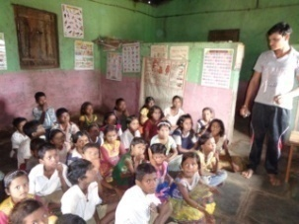 400 children benefited from support classes. 85% of the children improved in their studies and are regular in the school. 100% children are enrolled in the school. Children are improving in their studies especially they are motivated for higher studies. 40% children are enrolled and are studding in the Ashram and Sainik schools. 65% of the students have also grown in the leadership quality and coming forward in helping other students in their studies.

**Health & Nutrition:**

* Through ECC centers regular health check up of the children was conducted and weaker children were provided with tonic and required medical care in all the 10 villages. ANC and PNC mothers too have learnt to take care of themselves and their children. 80% pregnant women have learnt to go in for institutionalized deliveries. Through mobile clinics and medical camp, 85% people were treated and provided with medical care in all the 10 target villages.

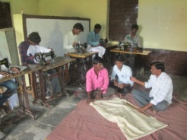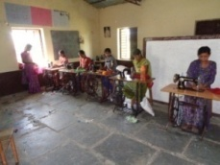**Vocational training: Skill and vocational trainings: -**

20 boys and girls are trained with stitching skill during this year in Mahagao and some of them have started earning. 5 girls were staying at Bhandaraj and did their tailoring.

**Community organization:**

* 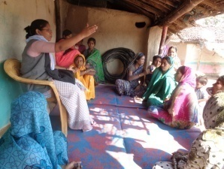There are 47 Self Help Groups of 484 women are the members of these groups. 10 Mahila madals in which 114 members are there. The entire SHGs do saving of Rs. 50 to Rs. 100 per month regularly. Up to now women have Rs.314785 savings in their bank accounts. Among them inter loaning has been done of Rs. 279900 of which almost is paid back regularly. Bank loan is taken of Rs. 111000 of which Rs.89000 is repaid. 87 women have taken up various Income generation programs and are earning their living.
* 10 farmers groups are encouraged and are motivated to do organic farming through various trainings, meetings and exposure programs.
* 10 youth groups and 13 Kishori groups are formed and are encouraged for higher education and also are motivated to participate in village development work.
* 24 children’s parliaments are formed and children are thought various values like important of education, climate change, cleanliness, and leadership for the village development through trainings, camps and monthly meetings.

**Various developmental programs:**

* Various watershed programs for the benefits of the villagers and farmers are conducted in these 10 villages, landless families are supported with Income generation programs, through various trainings motivated for their economical empowerment. Through village development committee thought leadership so that they could contribute for the development of their village.

**T.B. awareness programs:**

* 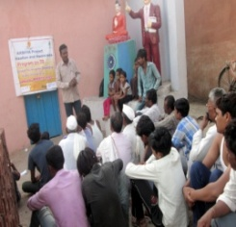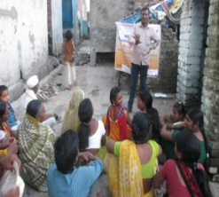TB awareness program has created awareness among the people of Anjangaon block. The program is monitored by staff from AXAYA New Delhi and district hospital. The awareness is being created among the people of Anjangaon villages. The symptoms and causes along with the free treatment are explained to them systematically. This has helped the people to accept one another and the number of patients has increased going for the check and for treatment. Monthly 2-3 awareness trainings are conducted in different villages for different stakeholders.

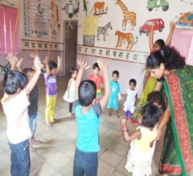**Asha Kiran Balwadi:-**

* 5 units of day-crèche with 125 are funded by State Social Welfare Board, Mumbai. The inspector Mr. More Sir from Mumbai inspected the units and was happy to see the improvement in the children. The children sang songs in English and Marathi and gave program during Christmas and 26 January in the village Panchyat. The children learnt to write, sing songs. The parents are happy to see the improvement in their children. Through this Balwadies the purpose of helping the working women is being fulfilled. From January 2016 the scheme is under change and now there are lot of expectation since the grant is increased and the salaries to the helper and teacher is increased.

**Sponsorship program:**

* 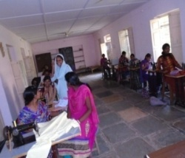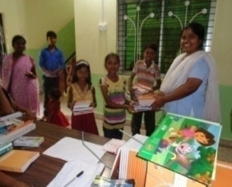 In the month of June the education materials like School bags, stationary, registers and note books and uniforms were distributed for all the children. The children are regular for the school and for the tuition. Three teachers are appointed to take their regular studies. Beside the three teachers one sister is kept especially to take English class. In the school they take part in various activities and they make a difference with their performances. Beside the coaching class the children are taught value education, cleanliness, gratefulness, love for prayer and helping one another.

**Tailoring Centre:**

* We had 35 girls in the tailoring class. The tailoring students who come from very poor interior villages are also helped for their future. After learning they take swinging machine to continue their livelihood and to support the family.

**II. MATRU SCHAYA HEALTH CENTRE, BHANDARAJ.**

* This year 14847 patients were touched and healed with compassion and love. Dr. Anju Minj along with the pediatric check up gives the health education on nutritious food. 4 deliveries were conducted in our hospital. Twice a week eye check up was done and 707 ophthalmic patients tested their vision and treated with the subsidized rate. 123 cataract surgeries were done through our center at Kottara hospital. There is a lab where we have done 1272 various lab investigations. This year 140 HIV test were done in our health centre and report sent to Irvin district hospital at Amravati. Through mobile clinic health check up, awareness programs on open defecation, communicable diseases, malaria, personal hygiene, ANC & PNC care and how to reduce the malnutrition.
* We also treat patients with acupuncture and acupressure. This year 415 patients has benefited from this treatment. Once a week there is a ayurvedic OPD through which 1000 patients were treated and 34 patients were treated with Panchkarma treatment. From our herbal garden plants 25 types of medicines were prepared and were provided for the patients.
* The other procedure of ayurveda is goldan drops which is provided for 0 to 16 year old children. 1049 children are given this therapy.
* Through nursing assistance course 10 girls are trained this year and through RANM govt. recognized course for 2 years 20 students are trained to support them to stand on their feet.

**III. MOTHER VERONICA ASHRAY KENDRA, BHANDARAJ**

* Mother Veronica ashram had 32 cases this year to which they counseled and helped. New 10 self help groups are formed with this people and through the help of Card sanstha 13 groups are given the loan of Rs. One lack on 1%. Various training programs are conducted to empower the women in the villages as well as in the centre. 3 girls are sent for the nursing at Panchgani Darshna.

**IV. ADIVASI VIKAS KENDRA SHIONDA**

**Distribution of Seeds:**

**Training On SHG**

**Children’s camp:**

. **Water facilities for the farmers:**

**Training on Government Schemes:**

**International Women’s Day**

**V. HOLY CROSS HEALTH CENTRE - SHILONDA**

**VI. Sponsorship program Report, Amravati**

**VII. DIVYA JYOTI SOCIAL CENTRE,** **MARTIN NAGAR, NAGPUR**

.

**COACHING CLASSES**

**YOUTH CAMP**

.

**WOMEN’S EMPOWERMENT**

**Beauty culture**

**Cutting and Tailoring:**

**Computer training**

**VIII. CHIKALDARA**

Roshni Seva \kendra conducted various activities for the betterment of young girls. 6 months tailoring course was a great help for young girls to learn stitching cloths, cooking, develop their skills, be confident and to stand on their own feet and support their families in future. At the completion of 6 months course the girls were provided with sewing machines so that they can stitch clothes and earn their livelihood.

**Grihini training:**

**VIII. ELECTION**

**IX: AUDITORS**

**ACKNOWLEDGEMENT**

**CONCLUSION:**

**M**atru Schaya Social Welfare Society strives to create an environment for holistic development of the tribal community through various projects and activities. Every member and the staff takes the responsibility of implementing the activities with whole heart and soul. People of the areas also cooperate and show interest for their growth and development. As the year has come to an end we feel very happy to children going regularly to the school and benefiting so much through the remedious classes. Women are growing in leadership and coming forward to take up various IGPs to sustain their families economically. Farmers too are not behind. They have got lot of knowledge through trainings, exposures and are striving towards organic farming. Youth are benefitting a lot as they are given various vocational skills to stand on their feet. Yes as we continue doing these good works we too have a lot of challenges like some of the people not having proper documents to benefit from Govt. schemes. Tribal’s do not open or express their views or problem thus it takes lot of time and energy to explain to them or to implement something with them. Children are not paid much attention due to parent’s unavailability and their illiteracy. Thus children don’t take much interest in their studies and it becomes difficult to handle them. Yet we do not give up but take courage and move ahead for we know one day our hard work will be rewarded. Once again we thank one and all for their support. **MAY GOD BLESS YOU.**

Sr. Sanjeeta Tigga